Unveiling Challenges of the External Trade in Bangladesh Amidst Current Dynamic Landscape

1. Introduction

Bangladesh's external trade faces critical challenges, including a gradual decline in trade orientation, limited export diversification, capital flight concerns, RMG sector issues, tariff liberalization hurdles, and weak participation in FTAs. With LDC graduation set for November 2026, these pressures will intensify. Addressing them requires comprehensive policy reforms, strategic investments, and stronger international engagement. Unfortunately, the previous government failed to address these issues effectively, leaving Bangladesh's external trade sector vulnerable and hindering its path toward sustained, diversified growth.

2. Seven Structural Concerns

2.1. Gradual decline in trade orientation

Figure 13.1 highlights Bangladesh's poor performance in trade openness, with a consistently low and declining trade-to-GDP ratio compared to Vietnam and India. While Vietnam’s ratio surpasses 150%, indicating a strong integration with global markets driven by its export-oriented industrial strategy and substantial foreign direct investment (FDI), in contrast, Bangladesh exhibited much lower ratios, averaging around 30%, reflecting limited trade integration. Bangladesh’s modest trade-to-GDP ratio suggests barriers to trade diversification and reliance on a narrow export base, particularly in the garment sector. More alarmingly, Bangladesh’s trade-to-GDP ratio declined quite significantly from 48.1% in 2012 to 33.8% in 2022.

Figure 13.1: Bangladesh’s trade to GDP ratio in a comparative perspective
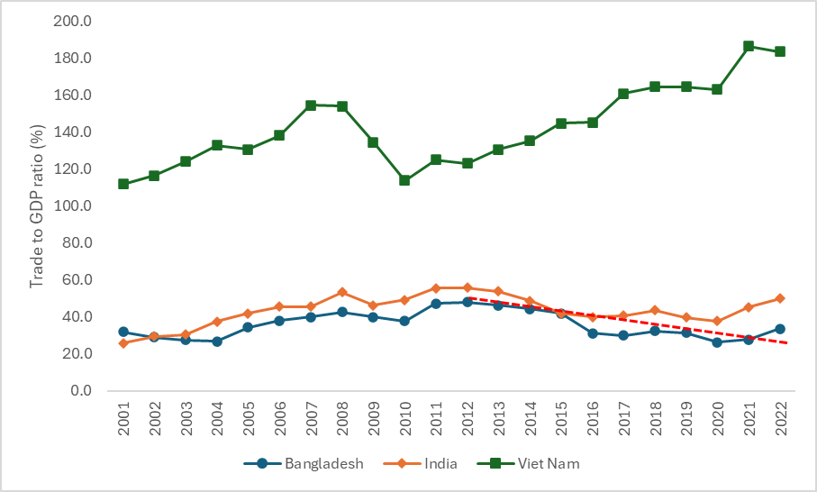
Data source: World Bank, World Development Indicators
Note: The dotted red line shows the declining trend of trade to GDP ratio of Bangladesh between 2012 and 2022

2.2. Export basket remains highly concentrated

Bangladesh's economy is heavily reliant on the Ready-Made Garment (RMG) sector, which accounts for over 85% of export earnings. While this sector has driven growth, dependence on a single industry poses significant risks, especially with external shocks like the COVID-19 pandemic or geopolitical disruptions affecting trade. Since the early 2010s, the share of RMG in total exports has grown from 77% to 86% by 2023, highlighting very limited success in diversification efforts (Figure 13.2).

Figure 13.2: Concentration of Bangladesh’s export basket: Percentage share of RMG exports in total exports
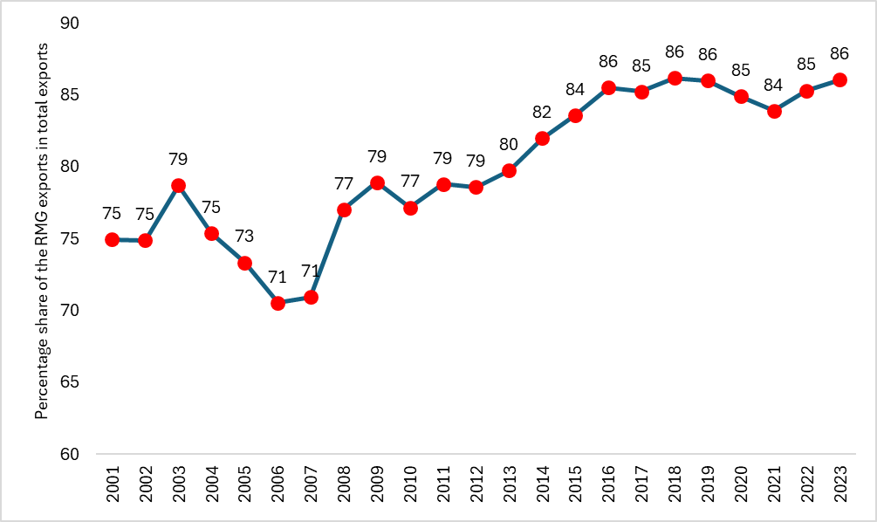
Data source: ITC TradeMap

Figure 13.3 presents a comparative picture of Bangladesh’s export product concentration index vis-à-vis its comparator countries. For most of the years between 2005 and 2023, Bangladesh’s export concertation index remained more than twice that of India, Indonesia, Vietnam and LDC average indices. While all these countries, in general, successfully brought the index down in the last decade, the index of Bangladesh remained high and rising.

Figure 13.3: Bangladesh’s export concentration index in a comparative perspective
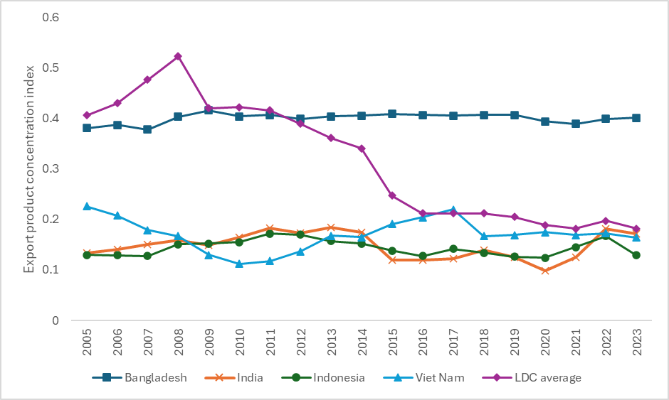
Note: Export product concentration index is derived from UNTADSTAT. The higher the index value the higher the concentration.
Source: https://unctadstat.unctad.org/datacentre/

Despite initiatives to promote sectors like leather, agro-processing, and light engineering, these industries faced challenges and remained underdeveloped. The leather industry, contributing 3-4% of exports, struggled with environmental compliance and skilled labour shortages. Similarly, the agro-processing sector was hindered by supply chain inefficiencies, insufficient technology adoption, and high tariffs on capital machinery, restricting growth.

Key barriers to diversification included high tariffs, complex customs procedures, anti-export and anti-FDI biases, and an overvalued exchange rate regime. These issues were often linked to political and economic elites' interests, while the government’s focus on large infrastructure projects overlooked sector-specific needs. Additionally, high business costs, outdated customs practices, and inadequate trade facilitation disproportionately impacted non-RMG sectors. Addressing these structural and policy-induced challenges required substantial investment and strong political commitment, which was lacking, further delaying diversification progress (Raihan, 2024). Table 13.1 summarizes the challenges faced by most of the non-RMG sectors in Bangladesh.

Table 13.1: Summary of the challenges faced by non-RMG exporters in Bangladesh
Challenges | Description
Infrastructure issues | Poor transportation, inadequate port facilities, and power shortages increase logistics costs and delays.
High logistics costs | Limited options for shipping and high transportation costs reduce competitiveness in the global market.
Access to finance | Difficulty in securing loans, high interest rates, and limited access to financial instruments.
Lack of product diversification | Heavy reliance on a few sectors, making them vulnerable to market fluctuations and limiting growth potential.
Bureaucratic red tape | Lengthy administrative processes, excessive paperwork, and delays in obtaining necessary permits.
Inadequate support for SMEs | Small and medium enterprises struggle with limited resources, lack of incentives, and insufficient government support.
Skilled labour shortage | Shortage of skilled labour in certain industries affects production quality and efficiency.
Regulatory compliance | Compliance with international standards and regulations is challenging and costly.
Exchange rate mismanagement | Exchange rate mismanagement impacts export earnings, making it difficult to plan and price products competitively.
Lack of technology adoption | Limited use of advanced technology and innovation hinders productivity and efficiency.
Marketing and branding challenges | Difficulty in establishing a strong international presence due to limited branding and marketing capabilities.

More critically, the dominance of crony capitalism over the past decade has hindered the growth of non-RMG sectors. Access to credit, tax benefits, subsidies, and various incentives often were determined by deals favouring cronies rather than a rule-based system, creating an uneven playing field that disproportionately impacted non-RMG industries (Raihan, 2024). Consequently, despite numerous diversification projects undertaken in the past decade (Table 13.2), the outcomes remained largely unsatisfactory.

Table 13.2: Examples of diversification projects
Name | Duration | Partners | Focus | Status of the project
Export Competitiveness for Jobs (EC4J) Project | 2017–2024 | World Bank | Enhance the competitiveness of key non-RMG (Ready-Made Garments) sectors, such as leather, footwear, plastics, and light engineering. The project aimed at skill development, infrastructure improvements, and market access. | Slow progress. The Daily Star in April 2023 that the project failed to meet its deadline and became costlier due to slow implementation.
Bangladesh Economic Zones Development Project | 2016–ongoing | World Bank, Japan International Cooperation Agency (JICA) | Establishment of special economic zones (SEZs) to attract foreign direct investment (FDI) in diverse sectors like ICT, pharmaceuticals, food processing, and electronics. The aim is to create export-oriented clusters beyond traditional sectors. | Only a few SEZs have become operational at varying scales. They haven’t been able to attract substantial FDI yet.
National Industrial Policy Implementation with a Focus on Export Diversification | 2010–2023 | Various UN Agencies (UNIDO, UNDP) | Policy reforms to encourage the growth of non-traditional export sectors, particularly ICT, pharmaceuticals, and light engineering. Supported the development of SMEs with export potential. | Challenges remained in implementing industrial policies due to a lack of ownership and coordination among line ministries and various stakeholders.
Skills for Employment Investment Program (SEIP) | 2014–ongoing | Asian Development Bank (ADB), Swiss Agency for Development and Cooperation (SDC) | Development of a skilled workforce for emerging sectors like ICT, light engineering, and agro-processing to support export diversification. | The Finance Division, Ministry of Finance, has been implementing this project and it doesn’t fall into the mandate of this ministry.
Bangladesh Investment Climate Fund (BICF) | 2007–2018 | International Finance Corporation (IFC), UK Aid | Improve the business environment to encourage investments in sectors beyond garments. Focused on regulatory reforms and infrastructure development. | The country lacks significant challenges in improving its investment climate and business environment. The World Bank’s ‘Bangladesh Development Update’ in October 2023 highlights relevant challenges.
Export Development Fund (EDF) Expansion and Upgradation | 2011–ongoing | Bangladesh Bank | The EDF initially focused on the RMG sector and was expanded to provide financing options for non-traditional export sectors, including leather, IT services, and jute products. | There have been allegations of mismanagement of EDF. According to the report by the Daily Star on 1 November 2024, a large chunk of a Tk 10,000 crore central bank fund, meant for financing raw material imports for export orders, remains stuck with four crisis-hit banks.
PFM II: Feed the Future Bangladesh Improving Trade and Business Enabling Environment Activity | 2019–2024 | USAID | The Feed the Future Bangladesh Trade Activity is working to improve trade facilitation through the implementation of the World Trade Organization (WTO) Trade Facilitation Agreement (TFA), building the trade facilitation capacity of government officials, and improving food safety procedures. | Complex customs processes, lack of cooperation among customs agencies, absence of automation, and unavailability of resources and information are the major challenges for Bangladesh to achieve the World Trade Organisation-Trade Facilitation Agreement.

Bangladesh has faced challenges in attracting foreign direct investment (FDI), which is essential for diversifying its export portfolio and enhancing economic resilience. Despite its potential, Bangladesh’s FDI-to-GDP ratio has persistently remained below 1%, lagging significantly behind regional competitors like Vietnam and India, where FDI ratios are around 4.5% and 1.5%, respectively. This limited FDI inflow restricted opportunities for technology transfer, industrial upgrading, and the expansion of high-value exports, all of which were vital for economic growth, export growth and export diversification.

2.3. Concerns over capital flight through over and under-invoicing

Bangladesh has faced allegations of large-scale capital flight over the past decade. Between 2009 and 2018, an average of $8.27 billion was lost annually through trade mis-invoicing, a common method of illegal capital flight, according to the Global Financial Integrity Report. The IMF also noted significant outflows from the financial account in FY 2022-23, amounting to 0.5% of GDP, alongside increased unrealized export proceeds, suggesting potential capital flight.

To address these issues, it is crucial to strengthen the capacity of institutions such as the NBR, the Export Promotion Bureau (EPB), and the Bangladesh Bank in terms of data collection, validation, and reporting. Currently, inconsistencies in data collection methods between the EPB and Bangladesh Bank contribute to these discrepancies. For instance, the EPB primarily relies on self-reported figures from exporters, which can sometimes be inflated for a variety of reasons, including obtaining favourable credit terms or maintaining client confidence. In contrast, Bangladesh Bank bases its data on foreign exchange earnings from exports, which provides a more reliable but delayed account of actual export performance.

Improving the technological infrastructure and coordination between these institutions is crucial for ensuring accurate and timely export data. For example, integrating digital tools for real-time tracking of exports and payments, along with cross-verification mechanisms between the EPB and Bangladesh Bank, could significantly reduce reporting errors. Furthermore, enhancing the human capacity of these institutions—by investing in training for data collection, analysis, and reporting—is necessary to ensure that data management systems can handle the growing complexity of global trade.

Equally important is ensuring that these institutions remain independent from political and business pressures, which can sometimes incentivize the inflation of economic indicators to project a more favourable image of the economy. Transparency in data collection processes and regular audits by independent bodies can help mitigate these risks and provide a more accurate picture of the state of the export sector.

2.4. Export data mismatch

In 2022-23, the gap between export figures reported by Bangladesh's Export Promotion Bureau (EPB) and Bangladesh Bank surged to $12 billion, up from $4.73 billion in 2020-21 (Figure 13.4). In July 2024, Bangladesh Bank released corrected data showing actual exports from July 2023 to April 2024 at $33.67 billion, significantly lower than the $47.47 billion reported by the EPB, revealing a $13.8 billion discrepancy. Such mismatches pose serious challenges for policymakers and investors, complicating economic planning and obscuring the true state of the export sector. This raises concerns about the robustness of Bangladesh’s economic recovery and resilience to external shocks.

Figure 13.4: Export data mismatch
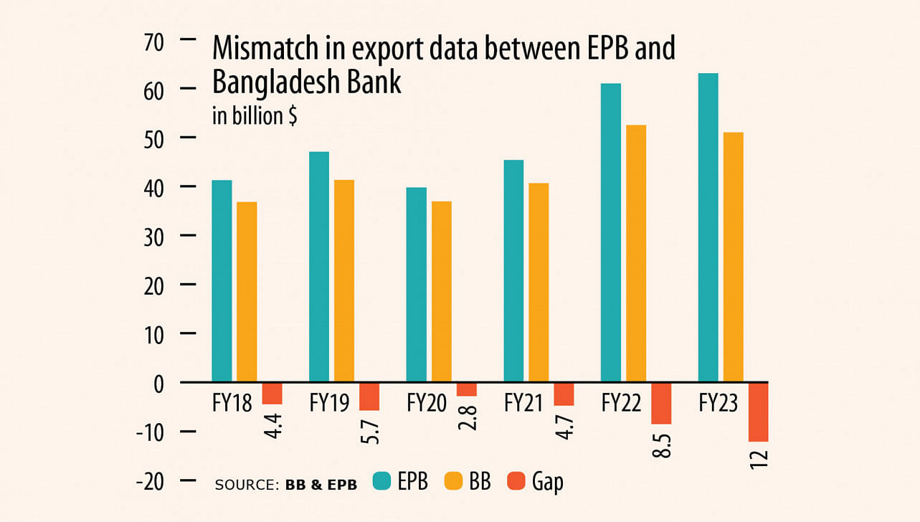
Source: https://www.thedailystar.net/business/economy/news/14b-export-data-puzzle-unnerving-3649186

The discrepancy suggests deeper systemic issues in export reporting accuracy. Observers have noted that export figures are often inflated, and exporters have struggled with rising production costs due to higher energy prices, wage increases, and global supply chain disruptions. Additionally, the demand for labour-intensive products, particularly apparel, has shifted toward more sustainable and ethically sourced goods, leading to difficulties in retaining global clients. Reports indicate that many RMG factories have reduced production due to insufficient orders and rising compliance costs. This disconnect between reported figures and on-the-ground challenges can result in misguided policies, masking the need for support in critical areas like financing, technology upgrades, and workforce development.

Inflated export data can also lead to misinformed decisions regarding foreign exchange reserves. Accurate export figures are essential for estimating foreign exchange inflows, which impact monetary policy and currency valuation. Over-reporting exports creates unrealistic expectations about the country's ability to manage its balance of payments, complicating fiscal and monetary planning.

To address these issues, it is vital to strengthen the capacity of institutions such as the NBR, EPB, and Bangladesh Bank in data collection, validation, and reporting. Currently, discrepancies arise from differing data collection methods; the EPB relies on self-reported figures from exporters, which can be inflated, while Bangladesh Bank uses foreign exchange earnings data, providing a more reliable but delayed account of actual performance.

Improving technological infrastructure and coordination between these institutions is crucial for accurate and timely export data. Integrating digital tools for real-time tracking of exports and payments, along with cross-verification mechanisms, could significantly reduce reporting errors. Investing in training for data collection and analysis would also help institutions manage the growing complexity of global trade.

2.5. Status of RMG export and associated challenges

The “RMG model” of export success in Bangladesh has failed to establish a sustainable path for export growth and diversification (Raihan, 2024). While it is often assumed that the RMG sector thrived solely due to favourable domestic and international trade policies, a range of additional factors were crucial to its growth. Key factors include the prioritization of the RMG sector as the main beneficiary of export incentives and industry and trade policies, favourable political settlements among the elites related to this sector so that political conflicts at the national level do not affect this sector, and the rise of subcontracting firms which could bypass many formal regulatory issues. The RMG sector also benefited from a "political settlement" among elites in labour management, which involved suppressing minimum wages, limiting workers' rights, and restricting trade unions. This was compounded by weak oversight of factory compliance, a lack of regulatory enforcement, and the extraction of rents through RMG by-products. The Bangladesh Garment Manufacturers and Exporters Association (BGMEA) emerged as a powerful lobby group with significant bargaining power, securing policies that favoured the sector. The influence of this sector extended to politics, with several garment owners becoming ministers and members of parliament, indicating a form of state capture by the RMG industry.

The RMG sector in Bangladesh also faces significant domestic and international challenges that threaten its growth and competitiveness. Domestically, labour rights remain a critical issue. Despite employing over four million workers, around 60% women, the sector has been criticized for poor working conditions, highlighted by the 2013 Rana Plaza tragedy. Although some progress has been made in factory safety through initiatives such as the Bangladesh Accord and Alliance, labour rights violations, including low wages, long working hours, and inadequate union representation, continue to be a concern (ILO, 2022).

Environmental compliance is another pressing issue. As global buyers prioritize sustainability, RMG factories face pressure to adopt greener practices. However, many small and medium enterprises struggle with the high costs of eco-friendly technologies and limited access to green financing. The lack of a robust regulatory framework further complicates the shift toward sustainable production (Light Castle, 2024).

Internationally, Bangladesh's RMG sector competes with low-cost producers like Vietnam, and Cambodia. Vietnam, with favourable trade agreements, has become a strong competitor by offering competitive prices and market access (Textile Today, 2020). Additionally, global supply chain disruptions and the shift towards nearshoring or friend-shoring, with a focus on sourcing from countries closer to their home markets, have changed sourcing patterns, challenging Bangladesh's position (McKinsey, 2022).

Evolving consumer preferences for sustainable apparel, especially in Europe and North America, add pressure. The upcoming EU Corporate Sustainability Due Diligence Directive will require supply chain compliance with stringent standards, risking the loss of buyers if not met (European Commission, 2023).

Bangladesh’s RMG exports also suffer from limited diversification within the sector. At the six-digit HS code level, just 10 RMG products account for 70% of the total RMG exports from Bangladesh (Raihan, 2024). As the RMG industry becomes increasingly saturated with cotton-based apparel production, it is crucial for manufacturers to diversify into non-cotton-based apparel, particularly man-made fibre (MMF), to retain Bangladesh's position as the second-largest RMG exporter in the global market.

Global trade tensions, particularly U.S.-China disputes, disrupt raw material supplies. Meanwhile, international trade agreements emphasize labour and environmental standards, requiring Bangladeshi manufacturers to upgrade compliance practices. A looming challenge is Bangladesh's LDC graduation in 2026, which will end preferential trade benefits, raising export costs and reducing competitiveness (Raihan et al., 2022).

2.6. Tariff liberalisation challenges

Bangladesh faces significant challenges in tariff liberalization, a crucial aspect of trade policy aimed at boosting global competitiveness. While reducing tariffs can lower the cost of imported raw materials, helping export-oriented industries, it also makes local industries vulnerable to cheaper imports. This creates a policy dilemma between protecting domestic industries and encouraging exports and foreign investment. Historically, Bangladesh’s tariff policies have been criticized for being inconsistent and reactive, failing to align with long-term economic goals (Sattar, 2024a).

Bangladesh's current average tariff rate of 27% is significantly higher than the averages of other income groups: 9.79% for low-income countries, 7.2% for lower-middle-income countries, 2.02% for high-income countries, and the global average of 6%. Over the past decade, the increase in para-tariffs, combined with customs duties, has led to a rise in the overall nominal protection rate (Table 13.3).

Table 13.3: Trend in Nominal Protection in Bangladesh
Fiscal year | Un-weighted  average custom  duties | Average  para-tariff | Average  nominal  protection rate
FY 01 | 21.10 | 7.13 | 28.54
FY 10 | 13.67 | 10.21 | 23.88
FY 15 | 13.16 | 13.53 | 26.69
FY 20 | 13.45 | 13.30 | 26.75
FY 21 | 13.58 | 13.50 | 27.08
Source: Sattar (2024b)

Bangladesh also has a very high share of tariff lines with international peaks (Figure 13.5). Between 2010 and 2020, the share of tariff lines with international peaks in Bangladesh increased from 39.7% to 40.1%.

Figure 13.5: Bangladesh also has a very high share of tariff lines with international peaks
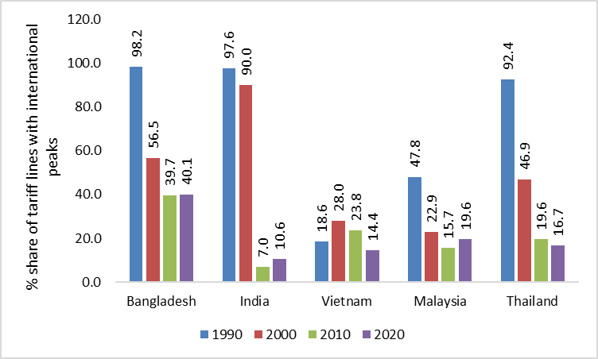
Data source: World Bank, WDI
Note: The share of tariff lines with international peaks is the share of lines in the tariff schedule with tariff rates that exceed 15%.

The country’s high average tariff rate is also because of the government's high reliance on revenue generated from customs duties amid poor performance in domestic revenue mobilization. Also, over the last decade, with the past government’s heavy focus on the development of physical infrastructure, import-substituting sectors like steel, cement, and construction materials always advocated for protection through high tariff rates. Some other import-substituting sectors like edible oil, sugar, biscuits, leather and leather goods, and poultry have also been in favour of high tariff protection.

This high level of protection has led to an "anti-export bias," where firms prioritize the more profitable domestic market over exports. For example, the RMG sector benefits from tariff reductions on imported inputs, but small and medium enterprises (SMEs) struggle to compete against imported goods, especially in sectors like light engineering and electronics.

The tariff structure’s high protection levels create disincentives for firms to innovate and seek new export markets, limiting export diversification beyond the RMG sector. Although periodic tariff reductions have been implemented to comply with international guidelines, these are often offset by non-tariff barriers such as high supplementary duties and value-added taxes. Such measures provide short-term protection to local industries but hinder the broader goal of creating a competitive, export-oriented economy (Sattar, 2024a).

Bangladesh’s tariff regime is further complicated by bureaucratic customs procedures, increasing the cost and time of trade. Despite efforts to streamline these processes, barriers persist, driving firms to focus on the domestic market, where administrative hurdles are lower (Raihan et al, 2023).

To address these issues, the National Tariff Policy 2023 aims to rationalize the tariff structure, reduce protection for final goods, and lower tariffs on raw materials and intermediate goods. This policy seeks to reduce production costs for exporters, enhance competitiveness, and attract foreign direct investment (FDI) by creating a transparent tariff environment (Khatun, 2024). However, the policy’s success will depend on effective implementation, which has often been undermined by vested interests benefiting from high protection levels.

Strong political will and collaboration among government agencies, industries, and trade associations are essential for gradual reduction and adjustment, encouraging competitiveness in domestic industries. Additionally, complementary reforms, such as reducing business costs, improving logistics, and strengthening institutions like the National Board of Revenue and Bangladesh Bank, are crucial to ensure the success of tariff liberalization and overcome the anti-export bias. Also, it is important to note that a more strategic rather than wholesale tariff liberalization policy should be promoted.

2.7. Limited participation in Free Trade Agreements (FTAs)

Bangladesh's trade policy faces a critical challenge due to its limited participation in Free Trade Agreements (FTAs). FTAs are essential in the global trading environment as they offer enhanced market access, reduce trade barriers, and improve competitiveness by securing preferential treatment for exports. Despite these advantages, Bangladesh has been slow in signing and negotiating FTAs compared to regional counterparts like India and Vietnam, limiting its ability to secure favourable market access globally (The Daily Star, 2024). There are six major reasons behind the low participation: (1) Preference for GSP benefits: Bangladesh benefits significantly from the GSP provided by major markets like the EU which reduces the immediate need for FTAs. (2) Fear of revenue loss: Since tariffs provide a large portion of revenue, policymakers in Bangladesh fear that the FTAs, which normally involve tariff reductions likely to have an impact on government income, will be economically unfavourable. (3) Trade negotiation capacity: The institutional capacity and negotiating skills in complex trade agreements haven’t been improved. (4) Concern for domestic industries: Many domestic import-substituting industries, fearing escalated competition, are not in favour of FTAs. (5) Concentrated export basket: Exports of Bangladesh are fairly concentrated, given that the RMG sector is dominant, and thus there is little incentive for opening up to other markets or sectors when such a diversified industrial base does not exist. (6) Political and strategic factors: Regional dynamics and alliances also influence Bangladesh’s cautious approach to FTAs, especially in balancing relationships with neighbours and trading partners in Asia.

Table 13.4: Bangladesh’s limited FTA participation
FTA | Description
Asia-Pacific Trade Agreement (APTA) | Formerly known as the Bangkok Agreement, APTA is a preferential trade agreement involving Bangladesh, China, India, South Korea, Laos, and Sri Lanka. It offers tariff concessions among member countries.
South Asian Free Trade Area (SAFTA) | A regional trade agreement among SAARC countries, including Bangladesh, India, Pakistan, Sri Lanka, Nepal, Bhutan, Maldives, and Afghanistan. It aims to promote trade by reducing tariffs among member nations.
Preferential Trade Agreement (PTA) with Bhutan | Bangladesh signed a PTA with Bhutan, marking its first bilateral trade agreement. The agreement provides duty-free access to numerous products between the two countries.

Bangladesh’s participation in regional trade agreements has been underwhelming (Table 13.4), with limited progress on agreements like the South Asian Free Trade Area (SAFTA) and the Bay of Bengal Initiative for Multi-Sectoral Technical and Economic Cooperation (BIMSTEC) FTA. SAFTA, signed in 2004, aimed to reduce tariffs and promote intra-regional trade, but progress has been hindered by non-tariff barriers and political tensions between member states (Raihan, 2020). BIMSTEC has similarly struggled, with delays in finalizing the agreement due to divergent national interests.

Bangladesh’s only notable bilateral trade achievement has been a Preferential Trade Agreement (PTA) with Bhutan in 2020, providing duty-free access for selected products. However, the agreement's scope is narrow, covering a small trade volume, and Bhutan's market size limits the economic benefits. Bangladesh has yet to sign comprehensive FTAs with major trading partners like the EU, the US, or China, critical for its long-term economic strategy.

The absence of FTAs has significant implications for Bangladesh’s export sector. Without them, Bangladeshi exports often face higher tariffs compared to competitors, such as Vietnam, which benefits from numerous FTAs, including the CPTPP and EU-Vietnam FTA. This has given Vietnam a competitive edge in sectors like textiles, electronics, and agriculture. As Bangladesh prepares to graduate from LDC status in 2026, the loss of trade privileges under the Generalized System of Preferences (GSP) will exacerbate this challenge.

To address these issues, Bangladesh must prioritize strategic engagement in FTAs, focusing on sectors with comparative advantages, such as RMG, leather, and agro-processing. It should seek to diversify its export markets by exploring agreements with emerging economies in Asia, Africa, and Latin America. Comprehensive consultations with domestic industries are also essential to ensure that FTAs provide sufficient safeguards for vulnerable sectors while encouraging competitiveness through investment in technology, skills, and innovation.

Recently Bangladesh also expressed interest in joining the Regional Comprehensive Economic Partnership (RCEP) and ASEAN. Membership in the RCEP will give Bangladesh expanded market access, particularly to major economies such as China, Japan, South Korea and members of ASEAN. Bangladesh is also considering FTA negotiations with some other countries. However, Bangladesh must strengthen its trade negotiation capacity, diversify exports beyond the RMG sector, and improve infrastructure to meet regional standards. Additionally, reforms in trade policies, tariff structures, and regulatory frameworks are essential to enhance competitiveness.

Bangladesh can also energize the SAARC and BBIN processes and expedite the BIMSTEC FTA by leading discussions on trade facilitation, cross-border connectivity, and streamlined customs processes. Prioritizing mutual economic gains, Bangladesh could propose joint investment projects, harmonized regulations, and capacity-building initiatives. Engaging stakeholders and leveraging diplomatic channels can drive progress and build regional partnerships.

3. Key Messages

- Export diversification: The government should undertake targeted policy interventions for the development of non-RMG sectors. This may involve a reduction of tariffs on imported capital goods, tax incentives, and support for technology upgrading efforts to raise productivity and competitiveness.

- Address the RMG-related challenges: To enhance the RMG sector's resilience, promote diversification into non-cotton and MMF textiles and provide financial incentives for compliance with international standards. Invest in technology upgrades and a green finance fund to support sustainable practices. Enforce labour standards and collaborate with global organizations to ensure ethical practices and improve buyer confidence.

- Smoothening the tariff structure: The government must remove the relatively "anti-export bias" by reforming the current high-tariff regime, particularly for raw materials and intermediate goods. Also, it is important to note that a more strategic rather than wholesale tariff liberalization policy should be promoted.

- Strengthen institutional capacity for data accuracy: The reinforcement of the institutional capacity in data accuracy requires further coordination and integration of technology at the EPB and Bangladesh Bank to reduce discrepancies in reporting relating to exports. In this respect, digitalized mechanisms may be provided for real-time tracking of exports along with the training provided in data collection and validation to enhance accuracy and transparency.

- Address capital flight through strengthened trade monitoring: Strengthen trade monitoring mechanisms to reduce capital flight through trade mis-invoicing. This could involve closer collaboration between the NBR, Bangladesh Bank, and customs authorities to enhance data validation processes, implement advanced digital tracking systems, and regularly audit trade transactions for accuracy.

- Negotiate strategic FTAs: Bangladesh should negotiate strategic FTAs with its key trading partners in preparation for the possible loss of LDC trade benefits in 2026. This negotiation must be sectoral, focusing on comparative advantages; the government must build negotiation capacity and strategy for favourable terms of trade.

- Enhancement in FDI attraction strategy: Government efforts to improve the investment climate by addressing infrastructural impediments, and red tape, and offering appropriate incentives in high-potential sectors will contribute to making Bangladesh a more attractive destination for FDI. It is also crucial to provide economic zones for diversified industries aside from the RMG sector to attract FDI and spur sectoral diversification.

References

ADB. (2016). Bangladesh: Consolidating Export-led Growth - Country Diagnostic Study. Asian Development Bank. https://www.adb.org/publications/bangladesh-consolidating-export-led-growth

European Commission. (2023). Corporate Sustainability Due Diligence Directive. European Commission. https://commission.europa.eu/business-economy-euro/doing-business-eu/sustainability-due-diligence-responsible-business/corporate-sustainability-due-diligence_en

ILO. (2022). Trade Union Organizing In Bangladesh’s Ready-Made Garment Sector Amidst Covid Pandemic: Status, Challenges And Scope. International Labour Organization. https://www.ilo.org/media/371121/download

Khatun, F. (2024). The new tariff policy may help increase competitiveness. https://www.thedailystar.net/opinion/views/macro-mirror/news/the-new-tariff-policy-may-help-increase-competitiveness-3400366

Light Castle (2024). Bunon 2030’s Policy Dialogue: Key Insights into the Future of Sustainable Apparel. April 2024. https://lightcastlepartners.com/insights/2024/08/apparel-sustainability-bunon-2030/

McKinsey & Company. (2022). The State of Fashion 2023: Resilience in the Face of Uncertainty. McKinsey & Company.

Raihan, S. (2020). Sustaining South Asia’s Regional Integration Process. In: Raihan, S., De, P. (eds) Trade and Regional Integration in South Asia. South Asia Economic and Policy Studies. Springer, Singapore. https://doi.org/10.1007/978-981-15-3932-9_1

Raihan, S. (2024). Informal Institutions, the RMG Sector, and the Present Challenge of Export Diversification in Bangladesh. In: Raihan S, Bourguignon F, Salam U, eds. Is the Bangladesh Paradox Sustainable?: The Institutional Diagnostic Project. Cambridge University Press; 2024:101-136.

Raihan, S., Khorana, S., & Uddin, M. (2022). Navigating LDC graduation: modelling the impact of RCEP and CPTPP on Bangladesh. Journal of the Asia Pacific Economy, 29(3), 1599–1621. https://doi.org/10.1080/13547860.2022.2114227

Raihan, S., Uddin, M., Hossain, I., Sharmin, E. and Aahad, MA (2023), “Expanding Private Investment in Bangladesh in the Context of LDC Graduation”, A report prepared for the Economic Relations Division, Ministry of Finance, the Government of Bangladesh.

Sattar, Z. (2024a). Changing trade policy directions is imperative now. https://www.thedailystar.net/opinion/views/news/changing-trade-policy-directions-imperative-now-3626601

Sattar, Z. (2024b). Looking for Trade Policy directions in the Forthcoming Budget https://policyinsightsonline.com/2024/05/looking-for-trade-policy-directions-in-the-forthcoming-budget/

Textile Today (2020). Why will Vietnam overtake Bangladesh in RMG export? https://www.textiletoday.com.bd/will-vietnam-overtake-bangladesh-rmg-export

The Daily Star (2024). Progress slow in signing preferential trade deals with trading partners. https://www.thedailystar.net/business/economy/news/progress-slow-signing-preferential-trade-deals-trading-partners-3714896

World Bank. (2023). Bangladesh Development Update: New Frontiers in Poverty Reduction. World Bank Group. https://thedocs.worldbank.org/en/doc/cf07cf58f2c345063c972a47209b8c11-0310012023/original/Bangladesh-Development-Update-October-2023.pdf

See the chapter on “Institutions” in this White Paper Committee Report for an elaborated discussion on how crony capitalism dominated in Bangladesh in the past decade.
Export competitiveness project still in slow lane after 6 years: https://www.thedailystar.net/business/economy/news/export-competitiveness-project-still-slow-lane-after-6-years-3293066
Only 10% of planned economic zones get off the ground in a decade: https://www.thedailystar.net/business/news/only-10-planned-economic-zones-get-the-ground-decade-3622336
Industrial Policy 2022: Coordination key to achieving implementation target: https://www.thedailystar.net/business/economy/news/coordination-key-achieving-implementation-target-3136196
World Bank (2023)
Tk 3,000cr export fund held up in four troubled banks: https://www.thedailystar.net/business/news/tk-3000cr-export-fund-held-four-troubled-banks-3741981
Many challenges prevent Bangladesh from achieving WTO-TFA: report: https://www.newagebd.net/article/195083/many-challenges-prevent-bangladesh-fromachieving-wto-tfa-report
See the chapter on “Illicit Financial Outflows” in this White Paper Committee Report for an elaborated discussion on the magnitude and processes of capital flight from Bangladesh in the past decade.
https://thefinancialexpress.com.bd/economy/numerous-rmg-factories-go-bust-amid-adversities
https://lightcastlepartners.com/insights/2024/09/rmg-man-made-fiber-sustainability/#:~:text=As%20the%20RMG%20industry%20becomes,exporter%20in%20the%20global%20market.
Bangladesh economy set to gain from RCEP’s diverse trade facilitation: https://www.globaltimes.cn/page/202410/1321410.shtml#:~:text=Membership%20in%20the%20RCEP%20will,percent%20of%20the%20global%20population.

